Suppl 21. Parsimony plot based on RF score importance ranking

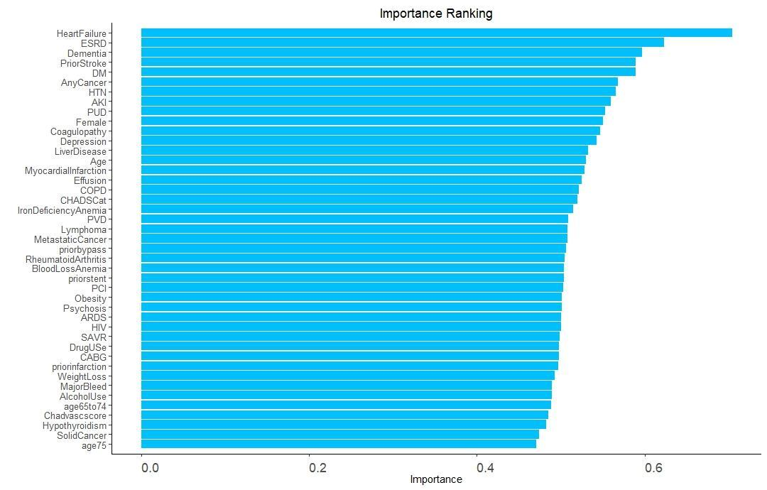

Note: A parsimony plot was generated based on the predictive ability of RF-score ranking importance. X-axis is the area under the receiver operating curve. Variables are listed in order of their predictive ability for stroke

