Suppl 24. ROC Curves for the new E-CHADS model. (A) shows the model’s ROC and 95% CI; (B) shows smoothed ROC curve; (C) shows ROC curve as evaluated on the test set, along with 95% CI

A
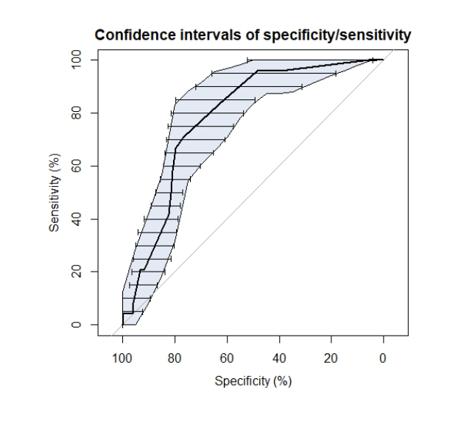
B C

