Suppl 6. Distribution of mortality outcomes by CHG quartiles in diabetes and prediabetes patients.

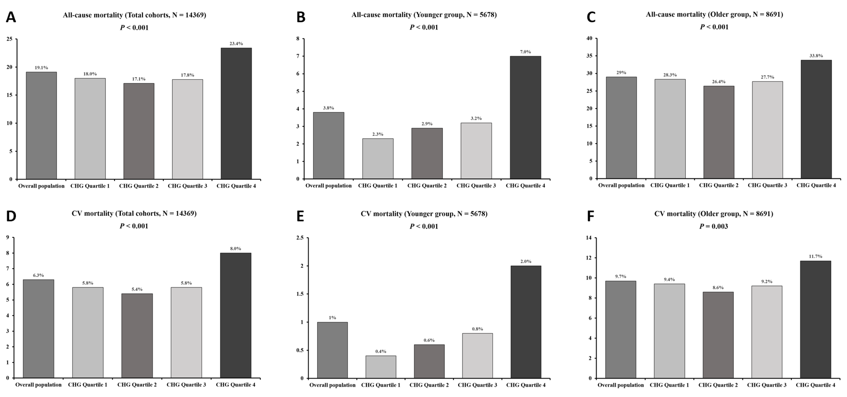
P values from the Fisher’s exact test

