Suppl 7. Association between CHG index and all-cause mortality (A) and CV mortality (B) in diabetes and all-cause mortality (C) and CV mortality (D) in pre-diabetes population.
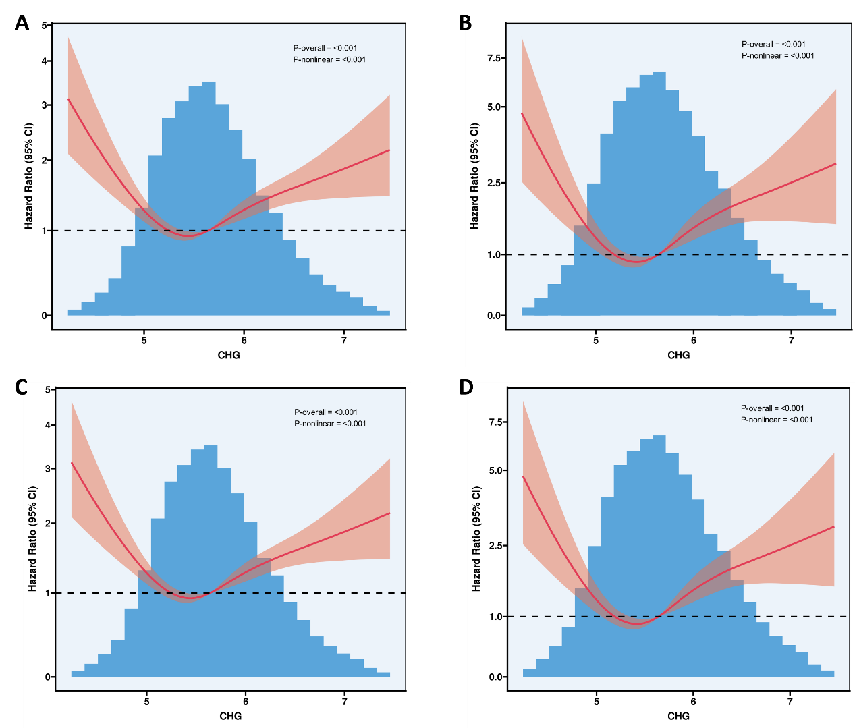
Adjusted for age, gender, race, smoking status, alcohol use, education, hypertension, family income-poverty ratio, Coronary Heart Disease, Congestive Heart Failure, Myocardial infarction, angina pectoris and stroke. The solid line and red area represent the estimated values and their corresponding 95% CIs, respectively.

