Suppl 8. Association of CHG index with all-cause mortality and cardiovascular mortality among diabetes or prediabetes population.

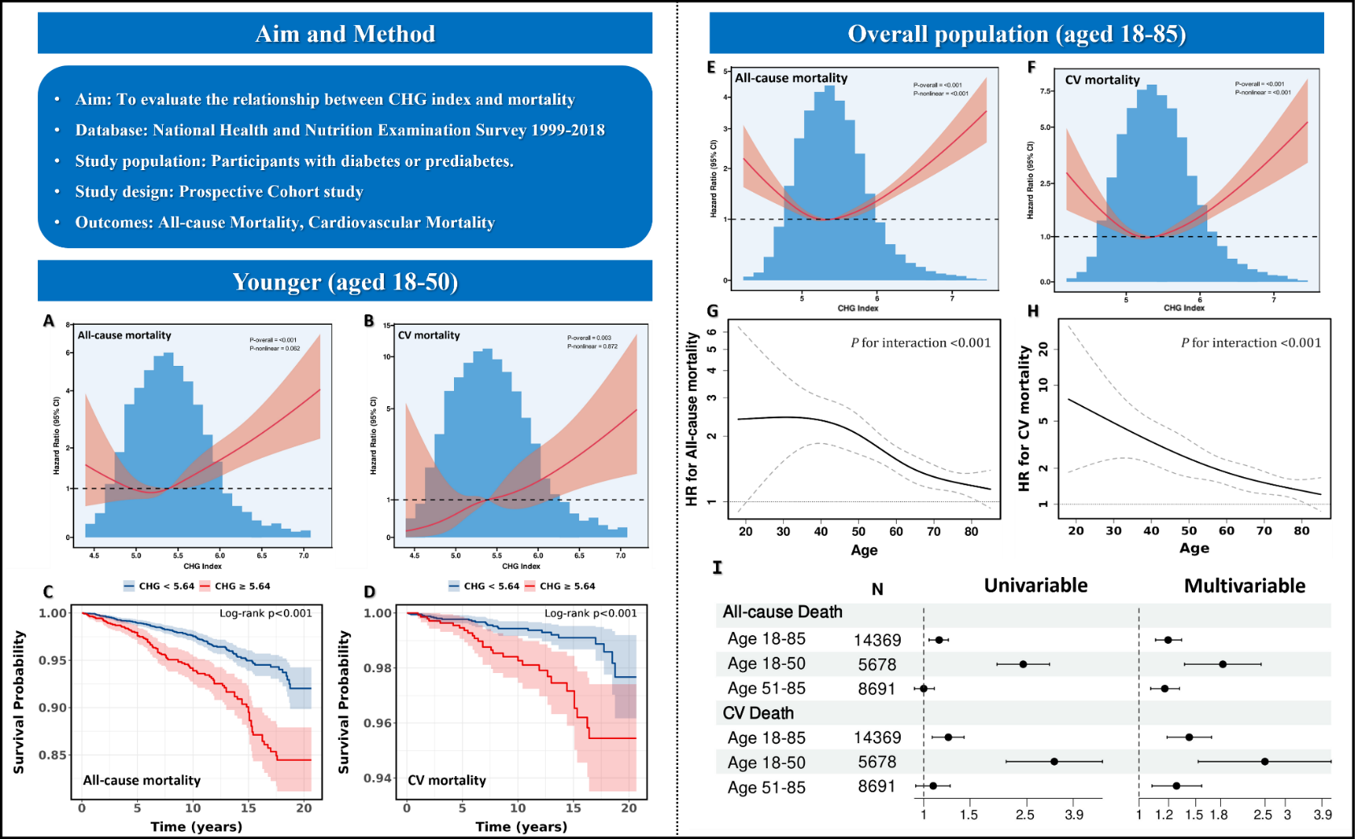
A/B: RCS models were used to study the link between CHG and mortality among individual aged 18-50 years. C/D: Kaplan–Meier survival curve analysis for the all-cause mortality and CV mortality. E/F: RCS models analyzed the relationship between CHG and mortality among individual aged 18-85 years. G/H: HR for mortality per 1-unit increase in the CHG index (p for interaction < 0.001). Derived estimates from Cox proportional hazards models, adjusted with restricted cubic splines featuring four knots at 5%, 35%, 65%, and 95%. I: Univariable and multivariable Cox proportional hazards regression models were employed to analyze the connection between continuous CHG and mortality.
A/B/E/F: The multivariable Cox proportional hazards models' P values were adjusted considering age, gender, race, education level, poverty income ratio, smoking habits, alcohol use, hypertension, and cardiovascular conditions.

