Suppl 7. Probability of patients remaining hospitalization-free according to PAPi quartile
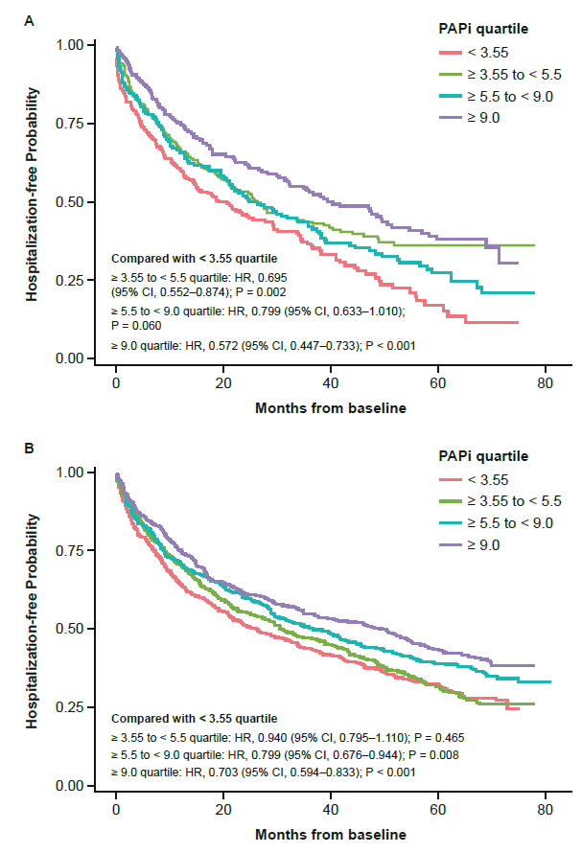

(A) Incident and (B) prevalent patients.
Incident cases were defined as patients who received a diagnosis of PAH confirmed by RHC during study recruitment; prevalent cases were defined as patients diagnosed prior to the start of the study [1].
CI: confidence interval; HR: hazard ratio; PAH: pulmonary arterial hypertension; PAPi: pulmonary artery pulsatility index; RHC: right heart catheterization.

Reference
1. McGoon MD, Miller DP. REVEAL: a contemporary US pulmonary arterial hypertension registry. Eur Respir Rev. 2012;21(123):8-18.

