Suppl 9. Histogram of PAPi scores/values
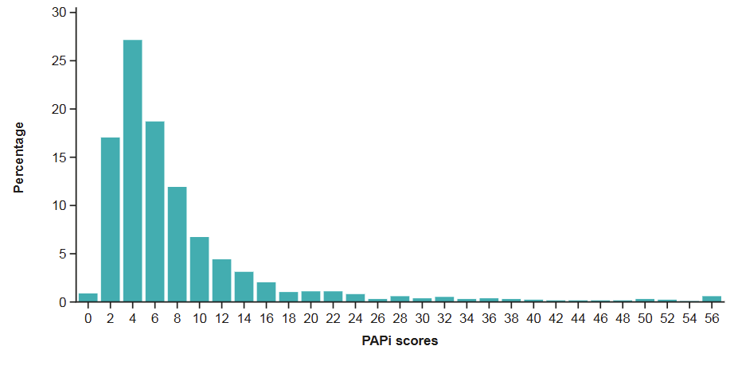
PAPi: pulmonary artery pulsatility index.

